Title of the extended abstract
Author 1^{a,b}, Author 2ª, Author 3^{b}
ª Affiliation a
^{b} Affiliation b
E-mail: E-mail address of the corresponding author
Keywords: Some keywords here

This template for the annual EAWE Ph.D. seminar shall be used in the preparation of the extended abstract when using MS Word. The total length of the document is max 4 pages for the extended abstract, including figures and references.

The format and typesetting of this abstract are listed below:

- Paper size is A4 with text width and height of 130 and 200 mm, respectively.
- Font to be used is ‘Times’ with justified side alignments and the font sizes are: Title 18pt., Author list and affiliations 14pt., E-mail address and keywords 11pt., Section titles 16pt., Text, figure captions and bibliography 10pt., Footnotes if any 8pt.

- The abstract title and authors should be in bold, and the presenting author should be underlined.
- Author affiliation is done with footnotes with the number format “a,b…” if necessary.
- Section titles (and subtitles) should be numbered 1. 2. ... (and 1.1 1.2 ...). They should be in bold.

- References are done with square brackets and the number format “1,2,…”. First letter of the first name and full surname of the author should be used, followed by the reference title. The journal name should come next and appear in italic, followed by volume and first page number, and finally the year.
See below for an illustration [1],[2].

Make sure that the labels and all other text in the figure/figures have readable and comfortable font size, i.e. not smaller than 10pt. Use a suitable format of the figure file.

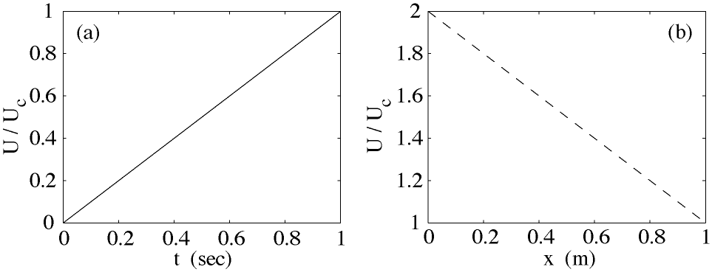

- (a) Velocity distribution in time. (b) Velocity distribution in the downstream direction.

To ensure that your extended abstract gets accepted, we advise you to follow some basic rules to guarantee quality of content. We are welcoming towards early stage researchers and the criteria listed below are by no means binding, but rather serve as a guideline.

- In general: be precise.
- No need to explain basic concepts.
- Structure your work clearly into sections
- Formulate a clear research question/multiple research questions.
- Formulate your (planned) research methods and why you are applying them.
- Formulate the context (be concise).
- Formulate expected outcomes.
- Language: English (be consistent if you choose for either US English or UK English).
- Cite the sources in a consistent way.
Acknowledgements
Acknowledgements, if any.

References
- B. Blocken. 50 years of computational wind engineering: Past, present and future. Journal of Wind Engineering and Industrial Aerodynamics, 129:69 – 102, 2014.
- J.-O. Mo, A. Choudhry, M. Arjomandi, and Y.-H. Lee. Large eddy simulation of the wind turbine wake
characteristics in the numerical wind tunnel model. Journal of Wind Engineering and Industrial Aerodynamics, 112:11 – 24, 2013

